Date 9 javascript code for variables output

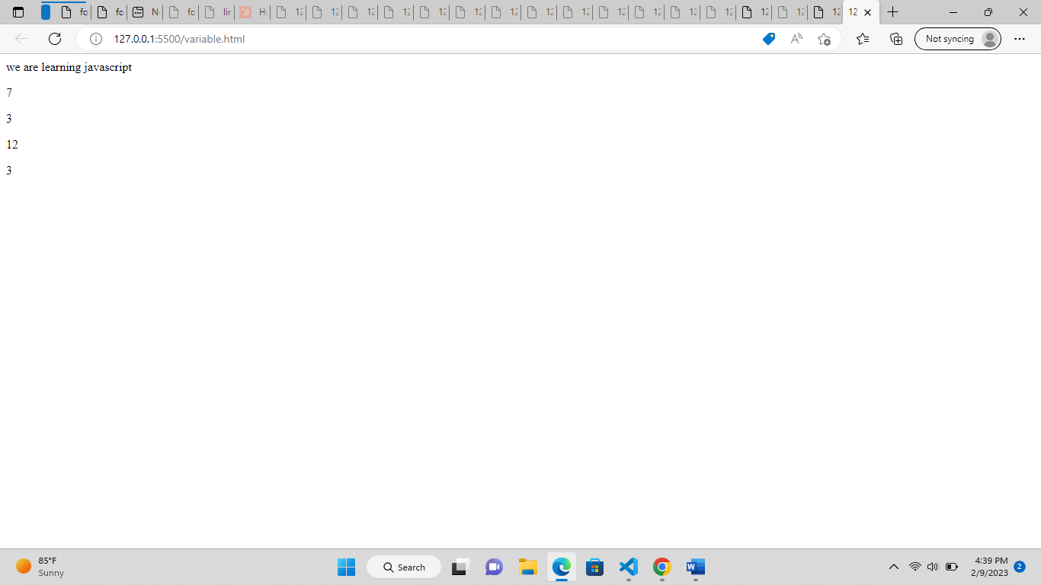

Webpage for forms-output

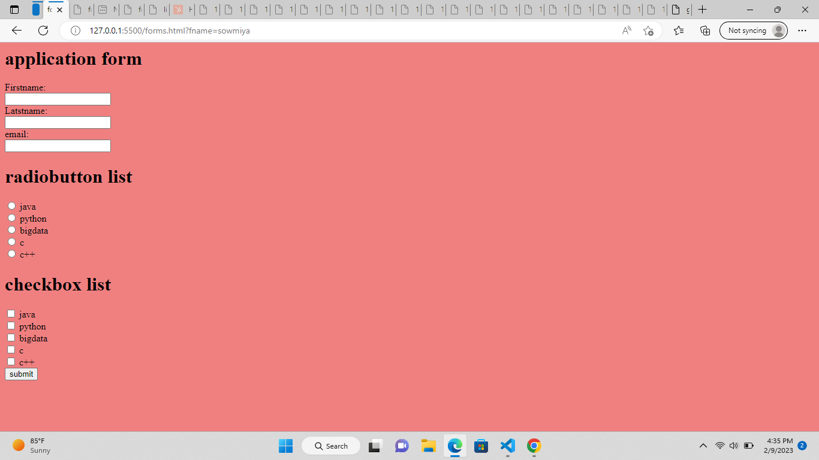

Output for inserting link

Active link

Visited link

